**Game of Trades: Using simulation to get an edge in the NBA trade market**

Basketball

ID: 5643

1. **Abstract**

In this paper I present a method to evaluate the impact of trades for NBA teams. Assessing the potential impact of trades is a complex task as it affects not only the composition of the teams involved but also the rest of the league. For instance, the Kyrie Irving – Isaiah Thomas trade not only affects how many wins will Cleveland and Boston obtain on the regular season but also has ripple effects and will alter the number of wins for any team playing these 2 teams.

The main idea is to estimate the offensive and defensive power of each team given the team roster and players’ minute share. Assuming the number of points a team scores follows a Normal distribution, the means are the offensive and defensive powers while the variance for both models is estimated from empirical data. Once the probability distribution is known, I can calculate the probability of any matchup and thus the number of wins in the regular season.

In the first part of the paper I will describe the proposed model and methodology. The second part is mostly devoted to examples and use cases. I developed an R dashboard[1] that I use to interact with the model and the data. I recommend the reader to play with it as you read the paper for a more interesting experience. All the code I used is available on my Github account: asRodelgo/NBA.

1. **The Data**

The basis of every statistical analysis in the paper is players’ main measurable stats. My only source of data is basketballrefence.com. There are many advanced statistics available however my goal was to have as many years of consistent stats as possible for all NBA, European and College players. This allows me go back in time to 1979-1980 where 3-point stats were first recorded. I also avoid stats that are not directly measurable from a player action, like box plus-minus. So, here are the stats I use[2]:

Age, G, MP, FG, FGA, FG%, 3PM, 3PA, 3P%, 2PM, 2PA, 2P%, eFG%, FT, FTA, FT%, ORB, DRB, TRB, AST, STL, BLK, TOV, PF, PTS

These variables measure per game stats but my interest is in stats per minute. I use the following nomenclature after transformation:

Age, FGPer, FG3Per, FG2Per, effFGPer, FTPer, effMin, effFG, effFGA, eff3PM, eff3PA, eff2PM, eff2PA, effFTM, effFTA, effORB, effDRB, effTRB, effAST, effSTL, effBLK, effTOV, effPF, effPTS

1. **The Model**

My objective is to model how many games will a team win in a given regular season. Because wins depend on the capacity of teams to score points scored and not receive them[3] I will model how many points will a team score (offensive power) and receive (defensive power) on average.

* 1. **Neural Network model**[4]

For each offensive and defensive power I will use the output of a Neural Network. For inputs I will use weighted average of players' projected per minute stats. Where weights are their share of minutes of play. Here are the steps I take:

1. Read historical players stats per game starting with season 1979-1980 from: <http://www.basketball-reference.com/leagues/NBA_2017_per_game.html>
2. Player name is my primary key so I need to differentiate players with the same name by adding a number after the name in ascending order by decreasing age. Example: Tim Hardaway who played in the 90s and Tim Hardaway 2 (current NYK player).
3. Calculate stats per minute of play (effBLK, eff3PM, etc) for each player i:

|  |  |  |
| --- | --- | --- |
|  | $${\text{effStat}}_{i}=\frac{{\text{effStat}}_{i}}{{\text{PM}}_{i}}$$ | (1) |

And effective minutes as MP (minutes played) over total possible minutes (48 minutes in 82 games):

|  |  |  |
| --- | --- | --- |
|  | $${\text{effMin}}_{i}=\frac{{\text{PM}}_{i}}{82×48}$$ | (2) |

Finally, adjust effMin relative to total minutes played by team Tm:

|  |  |  |
| --- | --- | --- |
|  | $${\text{effMin}}_{i}=\frac{{\text{effMin}}_{i}}{\sum_{i ∈Tm}{{\text{effMin}}_{i}}}$$ | (3) |

1. The input vectors for the neural network are the weighted average of all stats per team per season. The weights are the effective minutes. The total size of the resulting input vector is 1,063.

|  |  |  |
| --- | --- | --- |
|  | $${\text{effStat}}_{t}=\sum_{i∈{Tm}_{t}}{{\text{effStat}}_{i}×{\text{effMin}}_{i}}$$ | (4) |

1. Remove columns that depend linearly on others: FG, FGA, FG%,3P%,2P%,FT%,effFG%, effPTS and scale the data on [0,1] for easier convergence of backpropagation algorithm[5].
2. I use a split of 75-25% for the training-testing samples. Used 10-fold cross-validation with 10 repetitions (leave one out).
3. I train a regression neural network with 3 layers using the neuralnet[6] R package under default parameters defined by the caret[7] package. See Appendix A for details.
   * 1. **Results: Offense**

The best 3 models for points scored (offense) based on R-squared. Selected on top: (5-3-2)

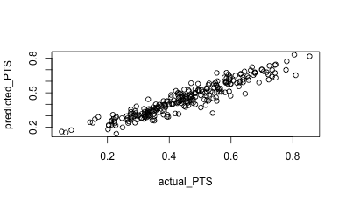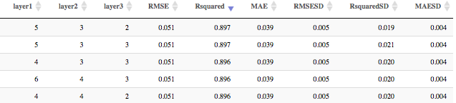

Fitted vs. actual on testing data (25% = 266 observations). Scaled to [0,1]

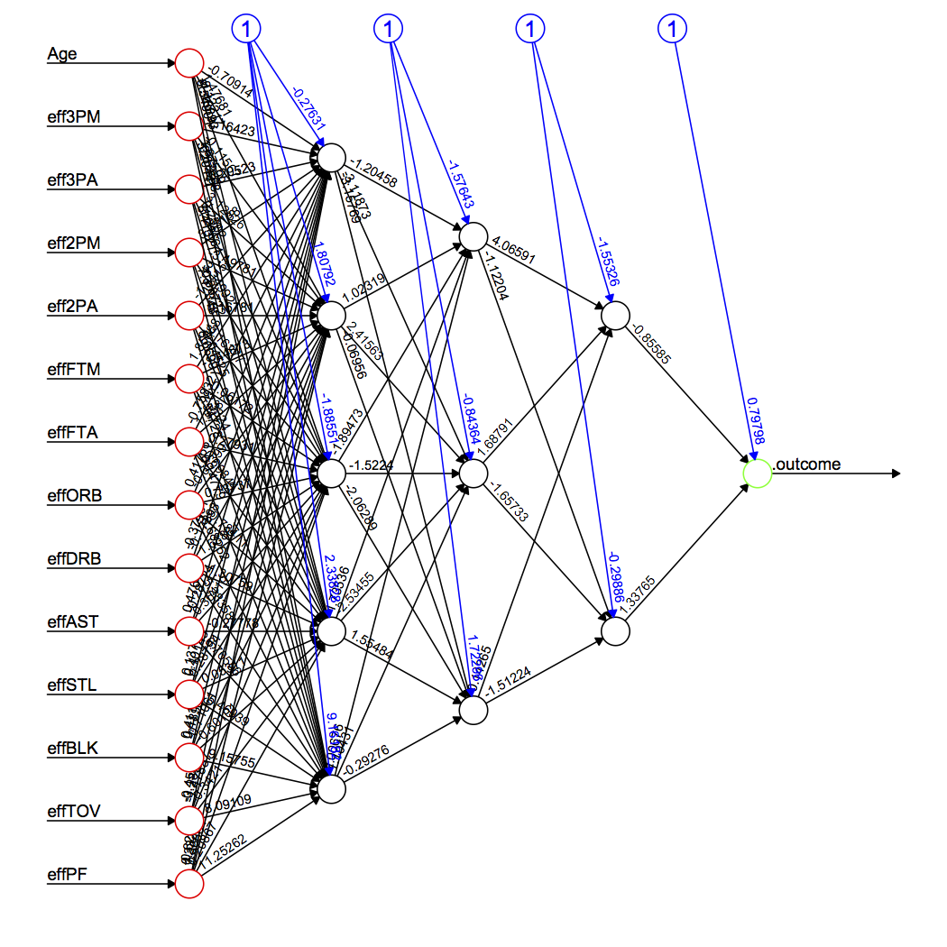

The Network. Visit the Model tab on the R Dashboard for details on weights connecting each of the nodes.

* + 1. **Results: Defense**

The best 3 models for points scored (offense) based on R-squared. Selected top: (4-4-3)

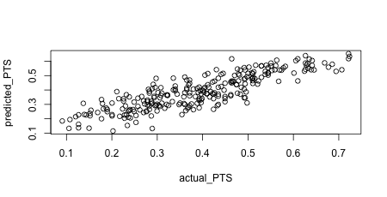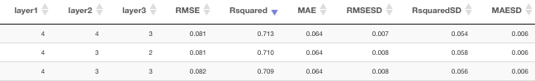

Fitted vs. actual on testing data (25% = 266 observations). Scaled to [0,1]. Clearly not as good a fit as the offensive model but still good enough.

* 1. **Probability model**

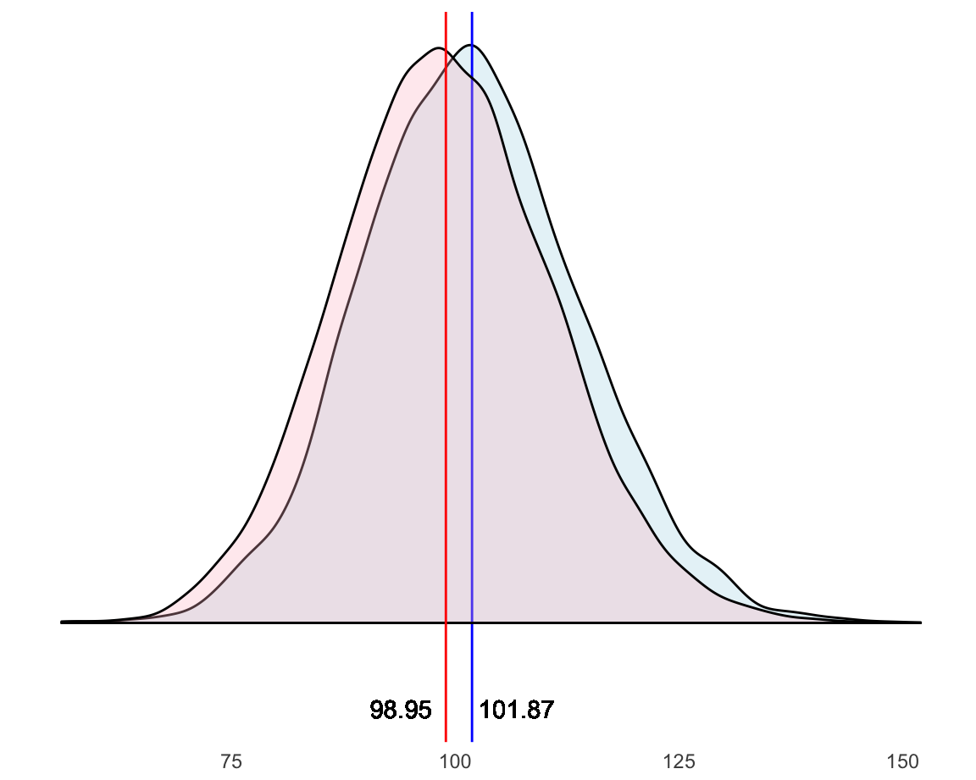Now that I have a way to estimate team’s offensive and defensive powers, I can use them as the estimated mean parameters of a Normal probability model. The choice for the Normal distribution is obvious if we explore the density of points scored by teams in the last 8 seasons: (since 2009-2010)

Where the blue density corresponds to points scored by home teams and the red density to away teams. The sample average is 100.41 with a sample standard deviation of 12.16. Now, the variance is pretty consistent across the sample (12.13 for home teams and 12.0 for away teams) and for simplicity I take the overall sample standard deviation as the estimation for the standard deviation of both Offense and Defense Normal distributions:

|  |  |  |
| --- | --- | --- |
|  |  | (5) |

* 1. **Wins**

So far I can calculate how many points a team score or receive on average, and I know the probability family that models these points. I have all the pieces I need to compute how many wins those offensive and defensive powers award. Suppose teamA plays against teamB and suppose teamA is the home team. I know how many points teamA scores on average, call it: ptsA. Empirically we saw in 3.2. how home teams score 1.46 more points on average. Call it: home_court_coeff. Next, I need to plug in teamB’s defensive power, call it: pts_agB. The higher the defensive power is, the worst the defense is (as opposed to offense). So, I will add this number to teamA’s offensive power. This will give me an astronomical number of points scored for a basketball game, which will be cancelled out when I calculate teamB’s offense. However, in order to be able to simulate realistic game scores I will subtract the overall average points (100.41) from that number. So, here is how to calculate a teamA’s points adjusted by home court and rival:

|  |  |  |
| --- | --- | --- |
|  | $${{Pts}^{*}}_{teamA}={Pts}_{teamA}+1.46+ {Pts_agst}_{teamB}-100.41$$ | (6) |

And for teamB as the away team:

|  |  |  |
| --- | --- | --- |
|  | $${{Pts}^{*}}_{teamB}={Pts}_{teamB}-1.46+ {Pts_agst}_{teamA}-100.41$$ | (7) |

Now I can plug these 2 measures as the estimated means of Normal distributions with standard deviation 12.16 and can calculate the probability of teamA beating teamB:

Let $X \text{≡ }Ν({{Pts}^{*}}_{teamA},\hat{σ}=12.16)$ and $Y \text{≡ }Ν({{Pts}^{*}}_{teamB},\hat{σ}=12.16)$ be random variables and P a probability measure defined on the space of all possible team matchup events:

|  |  |  |
| --- | --- | --- |
|  | P(teamA beats teamB) $=P(X>Y)=P(X-Y>0)$ $=P(Ν\left({{Pts}^{*}}_{teamA}-{{Pts}^{*}}_{teamB},\sqrt{2}×\hat{σ}\right)> 0)$ | (8) |

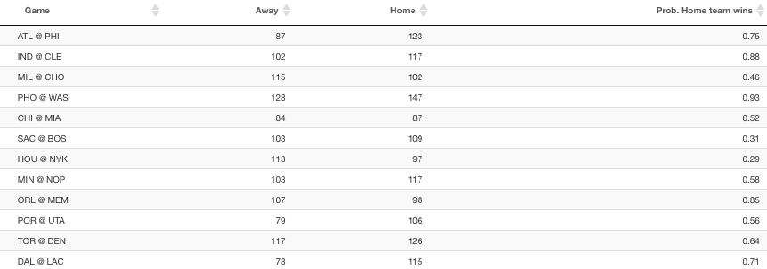If I calculate these probabilities for all games in a regular season, I can analytically obtain expected wins for each team. I will show the details in the results section below but as an example, take one random day in the regular season say, November 1. Here’s an extract from the R dashboard showing probabilities and simulated outcomes for each game:

I can easily then simulate an entire season and compute standings at any given point. Below the Eastern Conference standings as of November 1 according to my simulation:

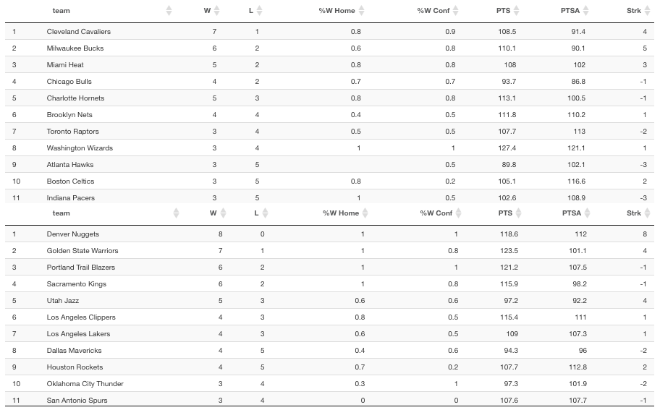

* 1. **Player similarity: t-SNE**

A quick aside before I continue describing the methodology. One of the key aspects of this model consists on being able to compare and classify players, and eventually teams. I use the t-SNE[8] algorithm to reduce the multidimensional space defined by players’ skills into 2 dimensions. In a 2-D space I can easily calculate Euclidean distances between players and at the same time visualize them.

The inputs to this algorithm are players skills and the output are x,y coordinates which we can map using a cloud of points. I use t-SNE in different situations which will be described below, in brief:

* Similar players by age: To predict how players’ skills evolve with age
* Similar players historically: To see players’ skills evolution over time
* Similar players for the current or any particular season: For clustering purposes

t-SNE algorithm is well described by its author on his page: https://lvdmaaten.github.io/tsne/. Also, [this article by Google](https://distill.pub/2016/misread-tsne/) provides more insights on how the algorithm performs and what the parameters mean. I’ll leave the details to the reader to not interrupt the flow of the paper.

* 1. **Building the roster**

So far, I used historical data to build a model that computes win probabilities based on team’s offense and defense. However, for this to be useful, I need to be able to predict these offensive and defensive powers based on the players that make each team at a given point. I need to do 2 things: Predict players’ skills and their usage or minutes share.

At the beginning of a new season we find 4 types of players:

1. Returning NBA players who played in the previous season
2. Returning NBA players who didn’t play in the previous season
3. Rookies drafted from American schools
4. Rookies from international teams

For each of these I will use a different approach mostly determined by the disparity of data sources. What follows is a brief account of the methodology, for a more detailed view and the R code please see Appendix A.2.

* + 1. **Returning players (cases a and b)**

The algorithm runs through all players from last season and calculates the closest 10 players overall for the past 5 years of his career: For each of the past 5 years of the player’s career I rank the closest players of the same age on that particular year according to Euclidean distance on the 2-D space defined by the t-SNE map of players of that age. I put them all together and rank them according to the number of times sum of the distances. This is inspired by FiveThirtyEight’s CARMELO[9] and it’s better explained through an example:

* 1. Take Bradley Beal from the Washington Wizards and take his last 5 years of NBA stats (from 19 to 23 years old).
  2. 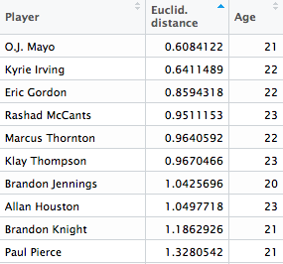Calculate closest players to Bradley Beal by age. That is, calculate the t-SNE 2D map for all the 23 year old players and keep the top 20 for each age. The output is a 100 record file like this:
  3. For each of the players calculate the average Euclidean distance and the number of appearances in the list. The more appearances and the lowest distance the higher in the rank. Here’s the top 10:

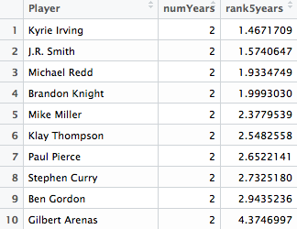

* 1. Bradley Beal will be 24 during this new regular season so for each player i in this list and for each of their effStats calculate the variation when going from 23 to 24 years old:

|  |  |  |
| --- | --- | --- |
|  | $${{∆effStat}^{i}}_{23-24}={({effStat}^{i}}_{24}-{{effStat}^{i}t}_{23})/{{effStat}^{i}t}_{23}$$ | (9) |

And then the median of all 10 players variations:

|  |  |  |
| --- | --- | --- |
|  | $${∆effStat}_{23-24}={{Median}_{i∈1:10}({∆effStat}^{i}}_{23-24})$$ | (10) |

Finally, update Bradley Beal’s stats according to this variation:

|  |  |  |
| --- | --- | --- |
|  |  | (11) |

* 1. The only constraint to the above approach is that players younger than 20 or older than 39 are so scarce that their t-SNE maps don’t really make sense so I assign players the latter to the class of 20 year olds and the former to the 39 year olds.

Sometimes a player didn’t record stats for last season, he played in another league or was injured. I use his stats in his last season as a player as their predicted stats.

For players with no previous experience in the NBA, I use the average player stats to predict their stats. Average player’s skills take the mean of all the numeric skills of all players’ stats from last season.

* + 1. **Rookie players (cases c and d)**

I retrieve rookie players from current rosters[10]. They are identified by an “R” in the Experience column. This file will not contain rookie stats for obvious reasons. I will merge this file with College Players’ stats[11]. Here are the steps I follow (For more details see Appendix A.2):

1. Query college players who played at least 15 games and 7 min/game last season. Totally arbitrary numbers under the assumption that if a player is fit for the NBA he would at a minimum played enough minutes. For those players who played for more than 1 season in college, I take the average of their career stats.
2. These 2 files are retrieved from different tables in basketballreference and sometimes their names are spelled differently. I have to manually change a few. See Appendix A.2 for details.
3. For international players I will query the European database of basketballreference[12].
4. There are always a few players for whom I couldn’t find readily available stats, if they are international players (playing in Europe or not) they are assigned the average of all the stats of players coming from Europe. For the rest (college players who for some reason were not matched or found) I assign the means of the stats of rookie college players.
5. Finally, because college and European players play fewer minutes, I need to take this into account when computing their minute usage comparable to NBA players. My take is this is the price they pay to jump into a more competitive league so I assume their effective per minute stats are based on 48 minute games, that is: effMin = MP/3936. Still, this is not realistic in most cases, as college players tend to play way fewer minutes on their rookie year than they would in college. To account for this discrepancies we can take a look at the percentage of minute reduction experienced by rookie NBA college players according to their draft pick. Data covers the last 20 years and it’s limited to players who played at least 30 games in their rookie year. Clearly, being a lower draft pick guarantees higher usage on the rookie year. Subsequently, I add the pick round to my dataset and adjust effective minutes based on the data below:



* + 1. **Putting it all together**

At the start of a new season[13], rosters are mostly final so the starting point is the most current NBA rosters. Merging this file with the previously calculated stats for returning NBA players and rookie players described in 3.5.1 and 3.5.2 will create the full list of predicted stats by player. Again, for details see Appendix A.2.

* + 1. **Adjusting player usage at team level**

So far the computed statistics and effective minutes of play were computed individually for each player regardless of the team they play for. Needless to say, teams composed of players who play heavy minutes will easily create an unbalance. The first step would be to transform minutes of play into percentage of playing time with respect with total team minutes.

This method will balance out the minutes but may not yet reflect a realistic distribution of minutes. Empirically, I looked at the average distribution of playing time. It is interesting to see how in recent years minutes of play become more spread throughout a roster. For instance, top 7 players accounted for 59% of total minutes on average in last 5 years while for the last 20 years, it accounts for 63%.

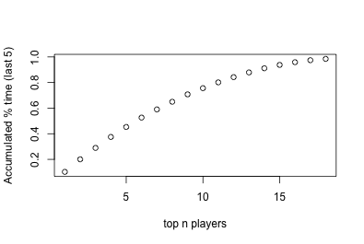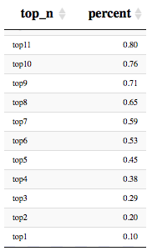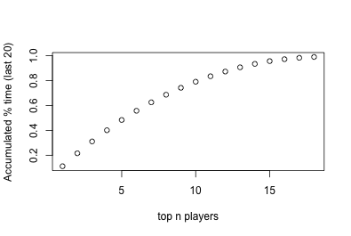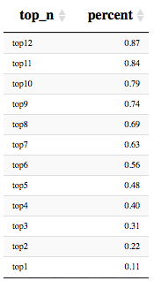

Considering this, I adjust playing time with the following parameters: top 7 players in each team sum up to 60% (round number in between 59% and 63% giving more preeminence to recent years) of total playing time with no player accumulating more than 10.5 % of it (averaging out top 1 percentage from both examples above). For instance, in a team with 3 star players, their total share of minutes may be as high as 31.5% leaving the remaining 28.5% for 4 players.

1. **The Results**

Once I define the probability model and the inputs, i.e., players’ stats and share of playing time, I can compute expected wins by running a simulation of the regular season using win probabilities. Interestingly, I can also treat players as if they were teams, that is, I can evaluate the offensive and defensive strength of players by applying the neural network model to them under the assumption they are “teams” composed of many versions of the same player. Example: How good offensively and defensively would a team be with 5 Kevin Durants on the court?

* 1. **The Teams**

With these premises I can already present some team stats in a dashboard. Below is the team dashboard for the Cleveland Cavaliers:

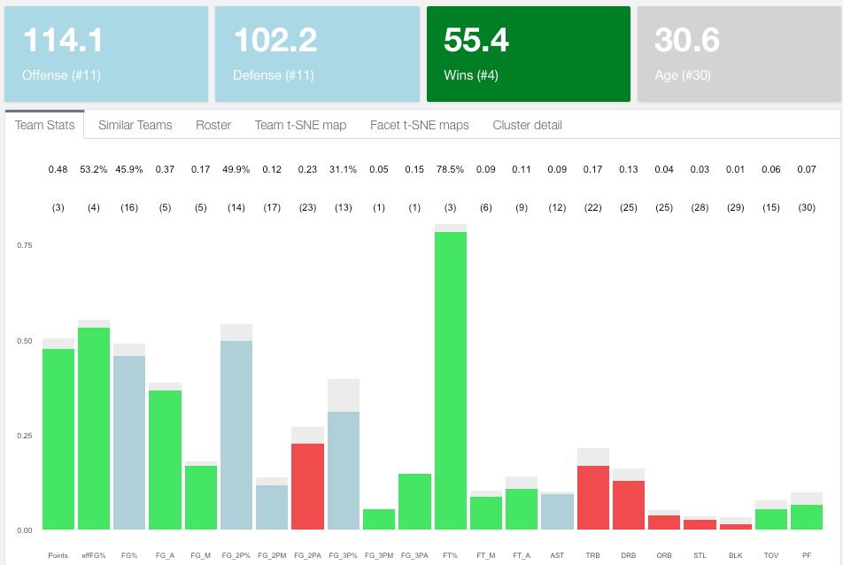

* + 1. **Team stats**

I rank teams in all categories and split them in 3: top third, middle third and bottom third assigning, respectively, colors green, light blue and red. In the example for the Cleveland Cavaliers, I can quickly spot strengths and weaknesses. My model gives them 55.4 wins in the regular season, they rank #11 in both offense and defense and they are expected to be #1 in 3 points made and attempted although only #13 in 3-point percentage. Clearly their weak spot is in rebounding, blocks and steals. Unsurprisingly, 2-point attempts ranks low as they are expected to be a shooting more 3s. Finally, they are the oldest team in the league averaging 30.6 years old.

* + 1. **Roster stats**

I can look at the team’s roster and individually spot offensive and defensive contributions and usage by player. Again, green means top third and red bottom third. Lebron, Isaiah and Love are all top 20 offensively and they all have a high usage rate as expected. Defensively, Tristan Thompson is their best asset ranking #12 in the league. Cleveland also features 2 players who are in the top third in both offense and defense which we will see is uncommon and provides great value added to a team: Kyle Korver and Channing Frye. Later in the player section of the paper I provide further analysis.

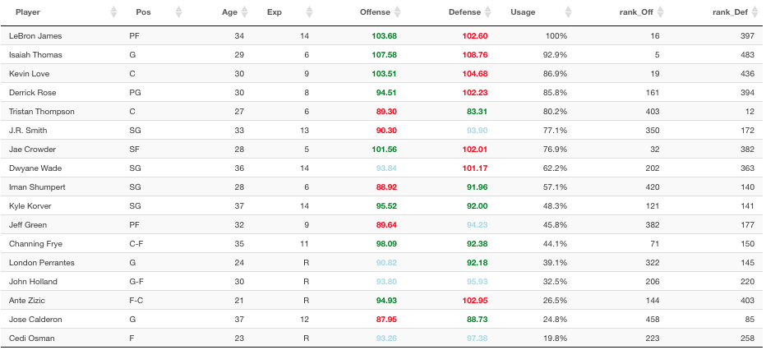

* + 1. **Team t-SNE map**

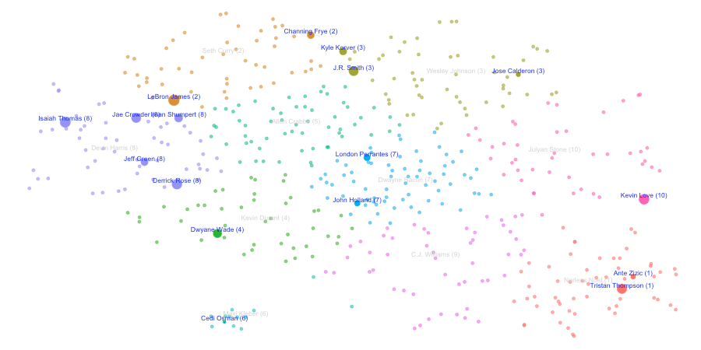Using t-SNE I can plot each player on a 2-D map and perform different exploratory and analytical analysis. This is how Cleveland players are distributed based on t-SNE. Colors correspond to K-means[14] cluster of size 10 and size of balloons to player usage

I could add more clusters or reduce the number of them. Clusters represent different types of players and in order to make a more informed decision on how many clusters (or player types) exist in the league, I can look at the stats that define each of the clusters. If we look at 10 clusters:

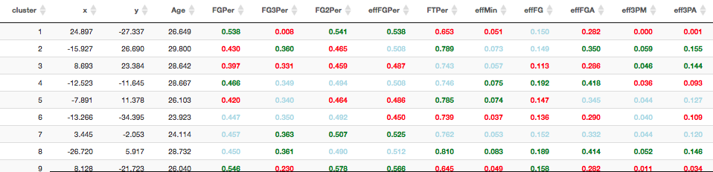This classification puts LeBron in the same cluster (2) as Channing Frye. A closer inspection shows that this is the group of veteran players that play low minutes and shoot from long range. They are also good on assist but don’t have great shooting percentages and don’t rebound, steal or block very often:

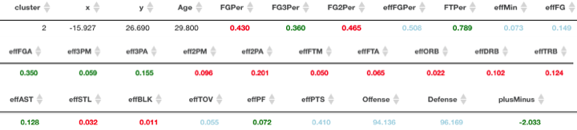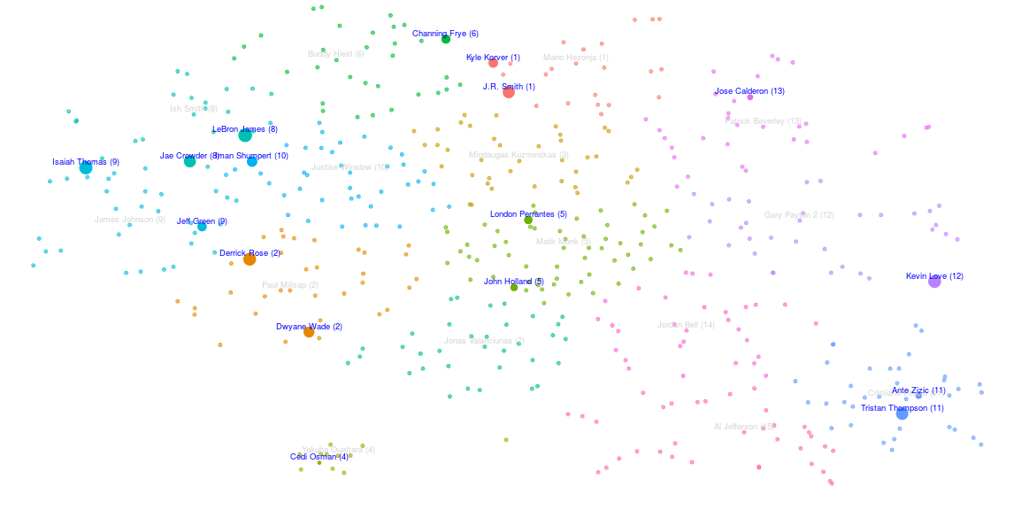

In my view a higher number of clusters will possibly represent the player typology better. See now for 15 clusters how LeBron is no longer associated with Fry but now with Jae Crowder.

Still not what one would expect. An interesting analysis would be to identify weak areas in a team and the type of player in the market that would fill that gap. I already know Cleveland’s weakness is in the rebounding, blocking and stealing areas on the defensive end but also needs to improve field goal percentages on the offensive end. If we look at the 15-cluster k-means detail, these are the clusters with better of those:

Clusters 11, 7, 15 and 14 fit the bill perfectly as almost all of those categories are green:



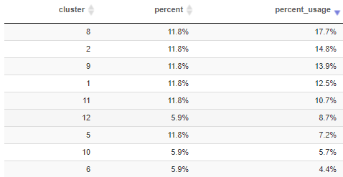Now I look at how Cleveland players are distributed across clusters by headcount and by usage, which is more important as we saw, to estimate wins:

Except for cluster 11, filled by Tristan Thompson and minimally by Ante Zizic, the rest of the clusters are not represented. I will go into more detail on how to look for players that fit a team’s needs. For now, I will move on to team similarities as an alternative way of assessing the winning potential of a team.

* + 1. **Team similarity**

When looking at the roster and structure of a team there is always a reference, the gold standard if you like. Arguably, in 2017, this is the Golden State Warriors and my model seems to back this up:

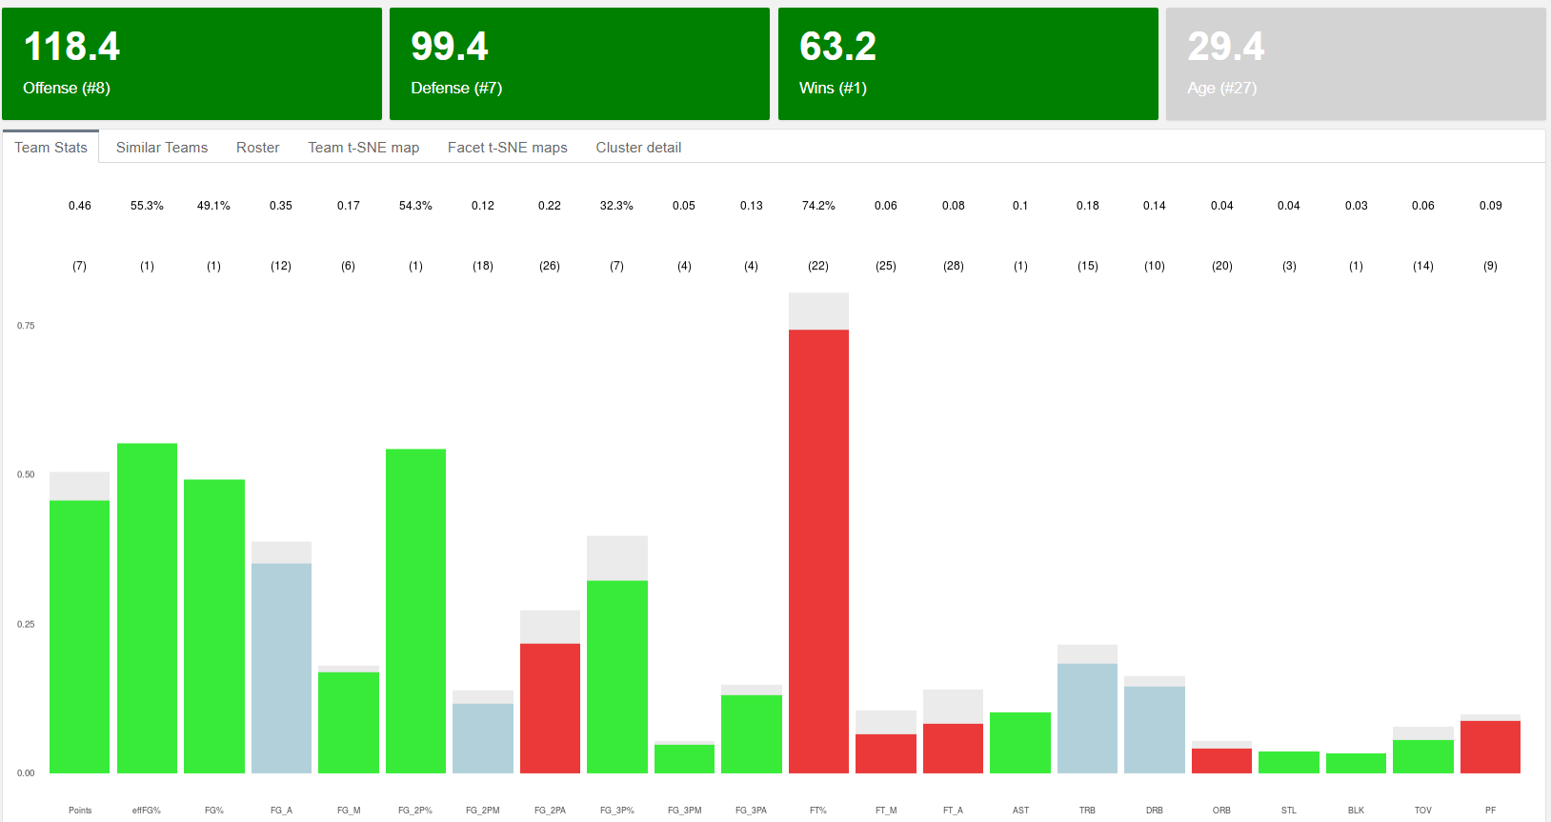

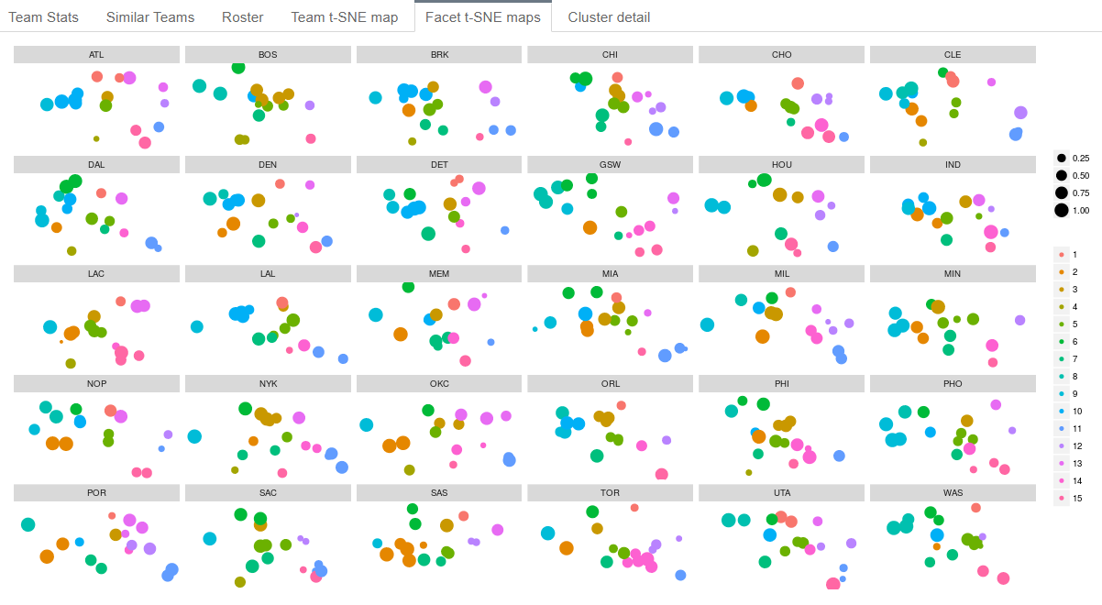As expected it’s green across the board and they’re number one in wins. They’re not perfect and they probably should improve on the free throw area but not much else. I would argue whatever shape they show on the t-SNE map should be close to an optimal distribution in the 2-D space. Here is Golden State’s distribution vs. the rest of the teams colored by 15 K-means clusters:

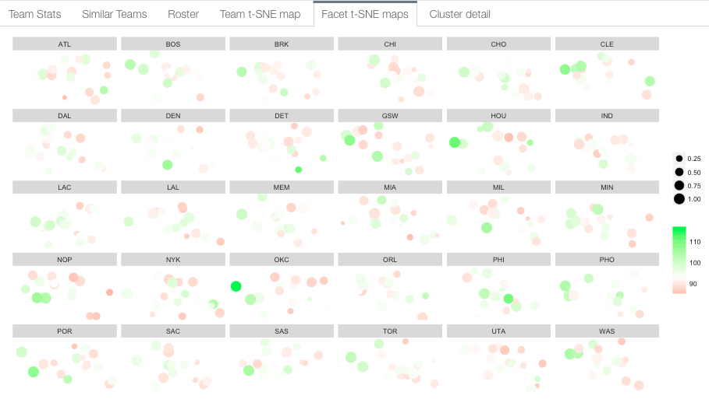Alternatively, I can use a gradient of greens and reds to spot offensive and defensive strengths or weaknesses. The image below corresponds to Offense (green is best):

Let’s take a closer look at GSW vs Cleveland:

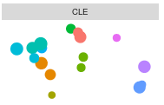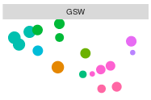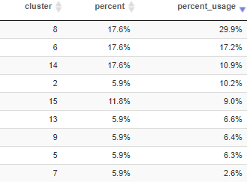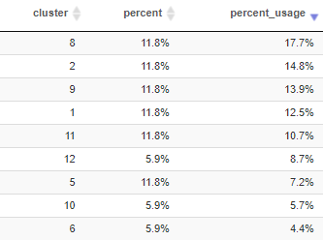

Totally different shapes, both winning teams but clearly GSW has been more successful lately. They seem to concentrate almost 50% of their usage on clusters 8 and 6 as opposed to barely 20% for Cleveland. I can look at the characteristics that define those clusters:



Cluster 8 corresponds to heavily offensive players, high in scoring and field goal percentage who play top minutes. Unsurprisingly Steph Curry, Klay Thompson and Draymond Green belong to it, as well as LeBron and Jae Crowder. On the other hand, cluster 6 is also characterized by 3-point shooters who play fewer minutes, more experienced players (Age over 31 on average) with good defensive skills. This is the realm of Shaun Livingston, David West or Nick Young versus Channing Fry in Cleveland. This analysis could continue in many different ways and it’s a lot of fun exploring the data using the R dashboard app.

But it’s really hard to measure the dissimilarity of shapes by just looking at the 2-D maps so I wanted to give an analytical measure. For this purpose I use a slight modification of the Bhattacharyya[15] distance to compare probability distributions of 2 given teams A and B:

|  |  |  |
| --- | --- | --- |
|  | $${\text{BC}}_{AB}=1000×\sum_{c=1}^{n}{\sqrt{\sum_{i∈c}{{effMin}_{i}^{A}}×\sum_{i∈c}{{effMin}_{i}^{B}}}}$$ | (12) |

Instead of counting the number of players that fall into each cluster, I use the accumulated usage percentage to better account for minutes played per position. The second modification is to use:

|  |  |  |
| --- | --- | --- |
|  | $${\text{Dist}}_{AB}=\frac{1}{{log⁡(1+BC}_{AB})}$$ | (13) |

Rather than the original as this will give me positive number always.

A visual exploration tells me that, for instance, San Antonio or the Clippers have a very different shape from Golden State. The analytical results confirm this. Besides, Cleveland is the furthest apart team from Golden State although that doesn’t mean much in terms of wins, only that they have 2 different winning styles. Actually, one of the closest teams to Golden State is Phoenix which my model predicts a very low number of wins.

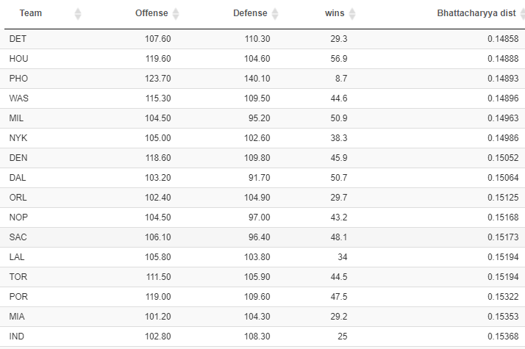

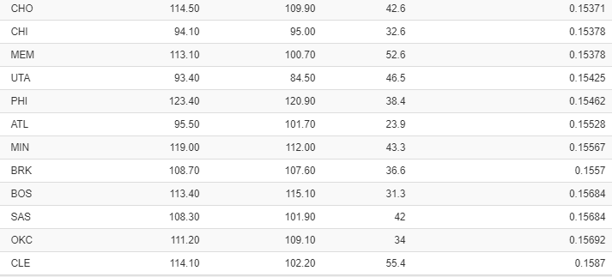

The final predicted wins for a team depend on many different factors, one being the accuracy of player predictions, which is particularly hard the younger the roster is (like Boston). Sometimes it’s also a question of how to optimally distribute minutes of play. Let’s take a look at Boston:

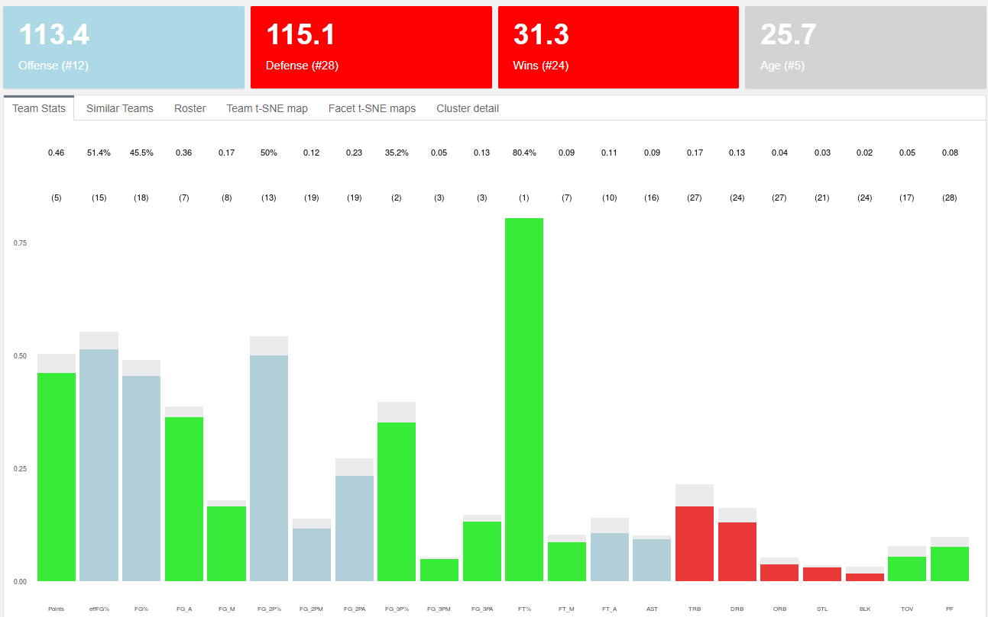

On paper, Boston looks pretty good across the board. Not many reds, very consistent overall. Looking at just the individual team stats one would think they should be expected to win more games than just 31.3. Before jumping to conclusions let’s look at the minute share in Boston’s roster:

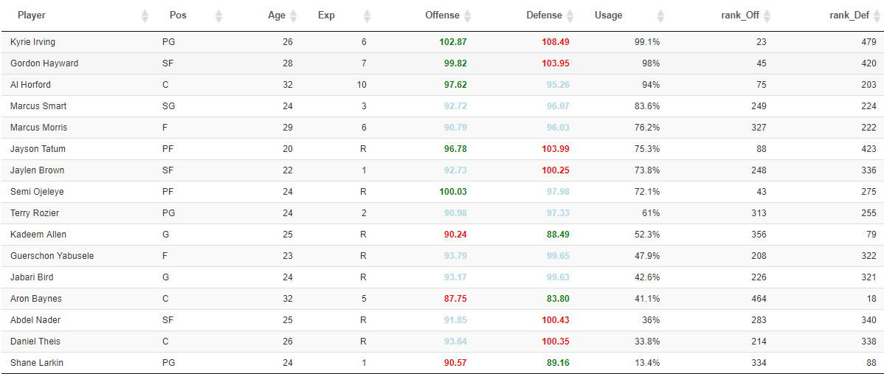

Boston’s offense ranks ok at #12 but their defense is the problem. According to the model, they are the third worst defense in the league. Looking at the roster, their best 3 defensive players: Allen, Baynes and Larkin are at or near the bottom in usage. This is a clear case in which a redistribution of minutes would possible benefit a team’s expected wins. I will actually test this hypothesis in the Trade section of the paper. Keep reading.

* 1. **The Players**

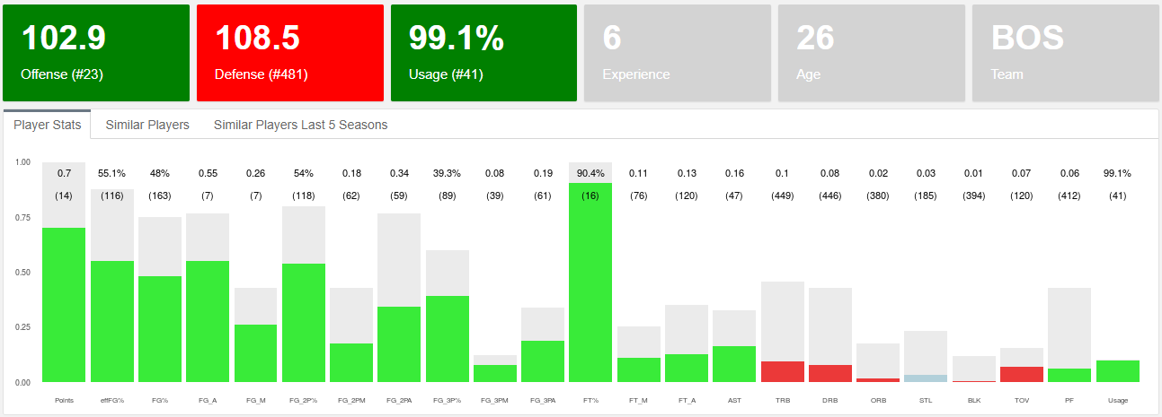Similar to the analysis we did for teams, we can do for players. As discussed above, I can apply the Offense and Defense neural network models to players under the assumption that they are teams composed exclusively of clones of one player. Imagine a team with 5 Kyrie Irving and a bench full of Kyrie Irvings. Well, let’s look at what the model would say about it:

A team full of Kyrie Irvings competing against regular NBA teams would be pretty good offensively but will struggle defensively as nobody would be able to protect the rim, grab enough rebounds, etc. That’s my interpretation of what the model shows.

* + 1. **Player plus minus**

This leads me to define what I call a player’s plus-minus, nothing to do with the Box plus minus used on regular stat sheets. I define plus-minus as the predicted Offense minus the Defense, which allows me to rank the best 2-way players and identify where potential improvements in wins can come from for each team. In addition, I also compute the adjusted plus-minus which accounts for the usage or minute share of each player. Here are the top 15 ranked players using both plus-minus (left table) and adjusted plus-minus (right table):

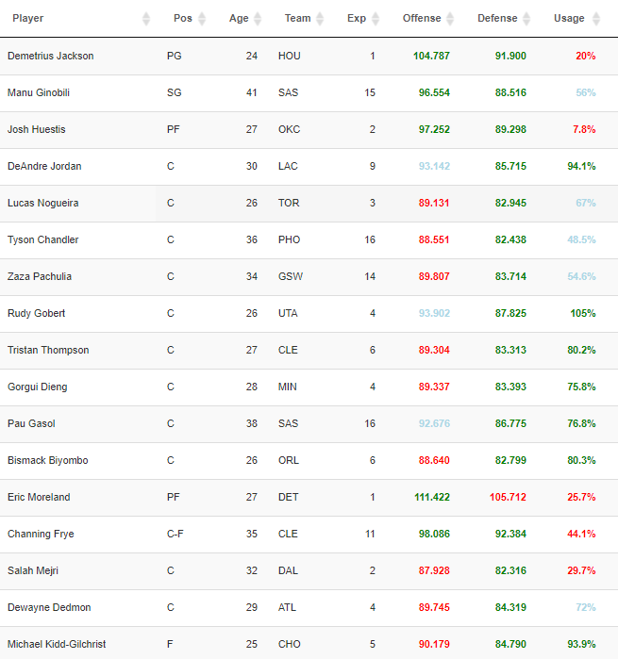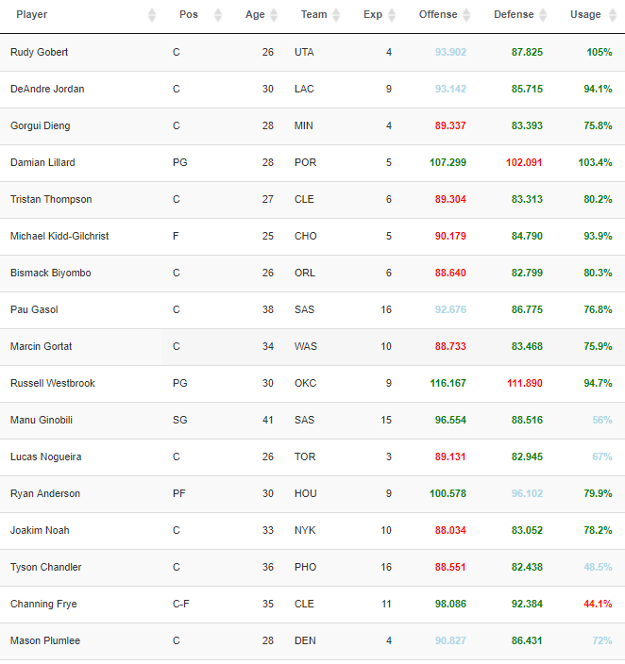

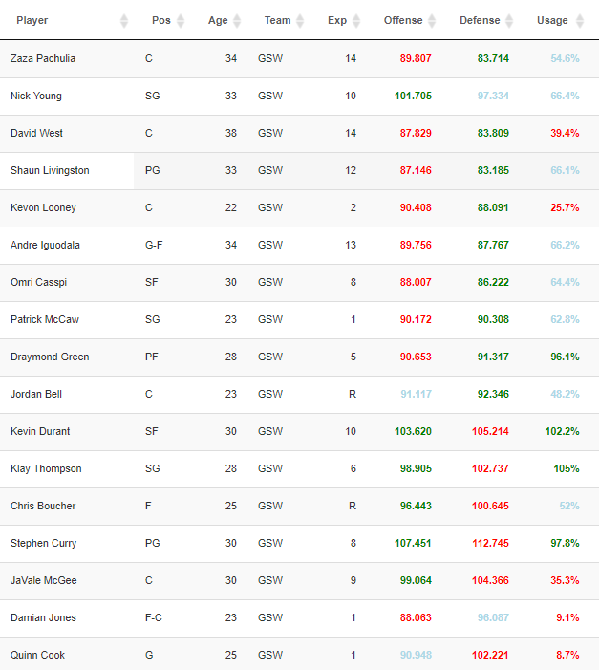Demetrius Jackson is the most valuable 2-way player according to the model, followed by Manu Ginobili and Josh Huestis. Both Jackson and Huestis have very low predicted usage in their teams so boosting their minutes of play would result in more wins for Houston and OKC, according to my model. When we look at adjusted plus-minus, it’s defensive giants like Gobert and DeAndre Jordan on top along with Tristan Thompson, or Bismarck Biyombo. But also small players like Damian Lillard or Russell Westbrook. GSW however is missing from the top 15 except for Zaza Pachulia. Why is this? A closer inspection tells me that GSW are actually the team with the most positive plus-minus in the league (7). And those who are negative, happen to be extremely good offensively, a lethal combination. The table on the left shows GSW roster details.

* + 1. **Player evolution**

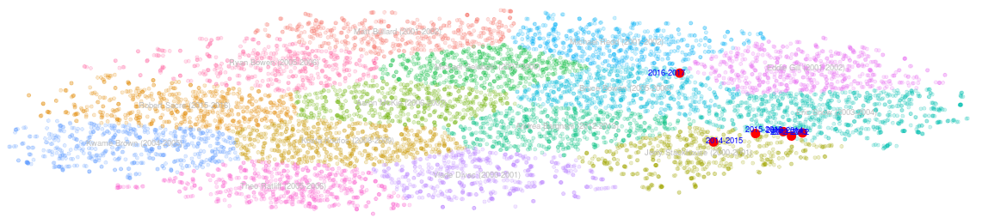But it would be premature to evaluate players by their plus-minus, especially those with little experience as their numbers respond to a smaller sample size. However, for those with a little more experience, we can look at the consistency of their game over time. I do that by computing a t-SNE model with all players for the last 20 seasons. The result is a 2-D cloud of points similar to the previous one with the advantage of seeing how players evolve over time. Let’s look at Kyrie Irving once again:

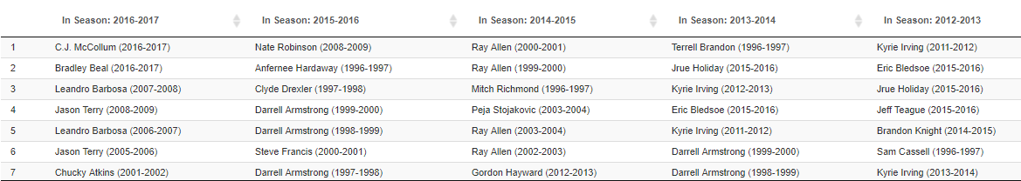His stats look pretty consistent throughout his career except for last season in which he clearly departs from the zone he used to dwell in. We can think of different reasons why this sudden change which definitely would have been a lot harder to spot by simply looking at his stat sheet, but let’s try to see this from the perspective of who were Kyrie’s neighbors (closest players by Euclidean distance) for the past 5 years:

Seems like a drastic change in neighbors from Clyde Drexler, Darrel Armstrong or Hardaway to C.J. McCollum, Bradley Beal or Leandro Barbosa. This seems to reinforce the opinion of Kyrie becoming more like a sidekick type of player next to LeBron and wanting out to be back in the vicinity of the greats.

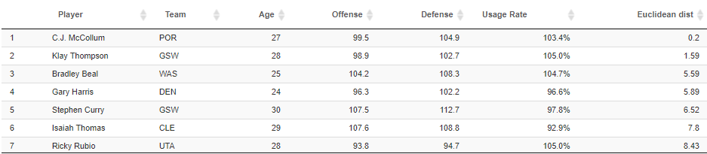Unsurprisingly, after applying the model and taking the t-SNE map of current predicted season stats, these are the predicted most similar players to Kyrie:

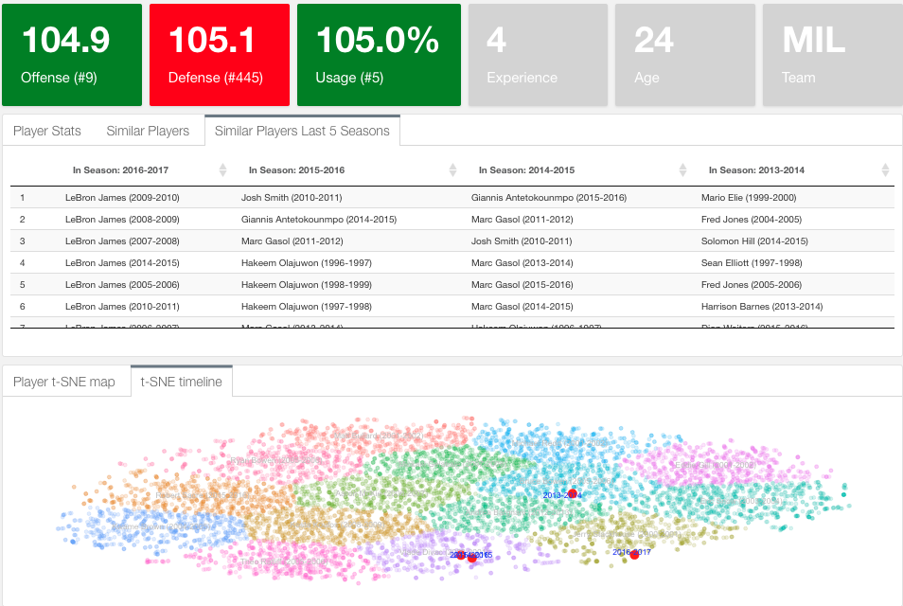Let’s now confirm analytically the evolution of two players who underwent big transformations: Giannis and Jimmy Butler:

Giannis path has changed significantly: From Marc Gasol to Olajuwon to being the closest player to LeBron James. Another interesting evolution happened to Jimmy Butler who basically moved from mediocre stats to the closest mix between Allen Iverson and Kobe we see in today’s game

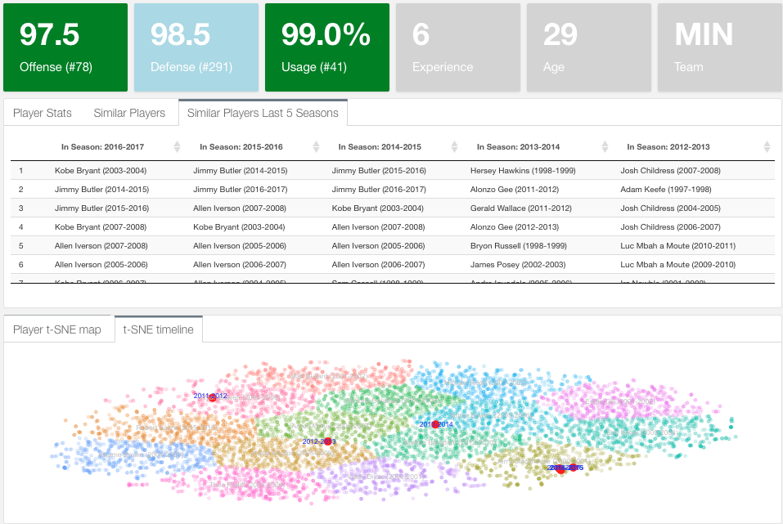I will finalize this section with a real case scenario. When the San Antonio Spurs had to explore the market for a replacement for Tim Duncan they didn’t use my model because it didn’t exist yet but probably used a similar one. Just check out below the most similar players to Pau Gasol. No comments:

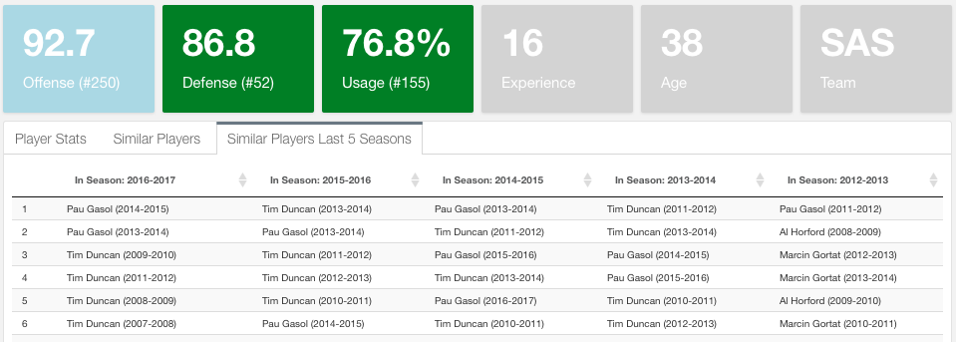

* 1. **The complete NBA t-SNE map**

Plotting all NBA players for the past 20 seasons on a 2-D t-SNE generated map provides a wide variety of possibilities. I have shown how we can trace a player over his career using this method. What we can also do is trace a team or a certain style of play over time. I will show how the 3-point shooting has shaped the game in recent years:

First of all, identify where does the 3-point shooting territory falls in the map: color by 3-point attempts where red is most:

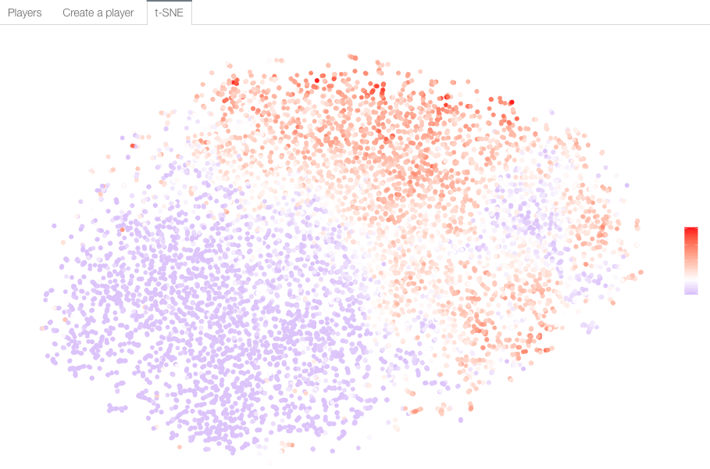

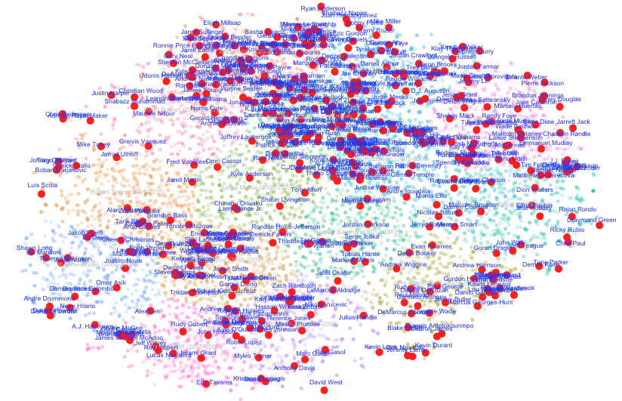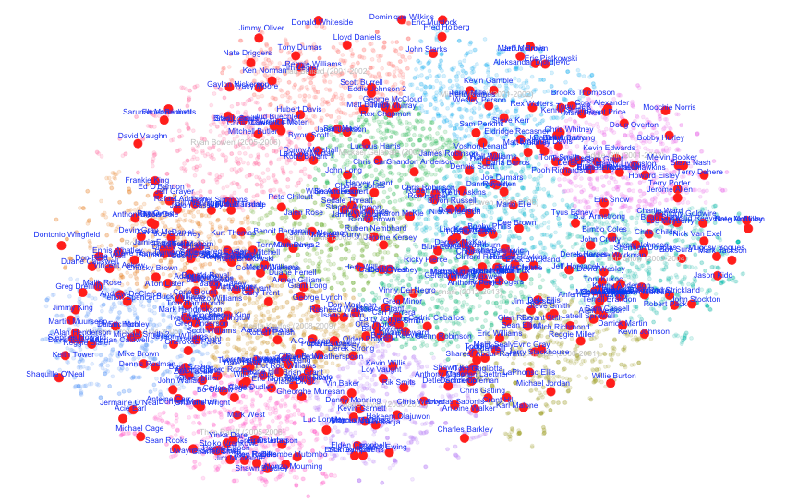Now see how players lean towards the red region over the years. The left hand side picture corresponds to the 1996-1997 season. The image to the right to 2016-2017 season:

1. **The Trades**

The results section set the tone of the type of analysis that can be performed with the described model. The next step if to test some of the hypothesis presented and the robustness of the model. I will start by defining what is a trade: I consider a trade any change in the roster of a team that affects their Offense and Defense powers. In particular, a trade may be the traditional trade of 2 or more players between 2 or more teams. Can also be a player leaving a team and the league (due to injury, retirement or traded to another league). Finally, it can also be a player who increases his usage within his team.

The key aspect of a trade is that when it does happen, the whole league stats and team rosters are re-calculated as a change in a team’s Offensive and Defensive power will affect not only their number of wins but also every other team’s number of wins. Now let’s get to the examples:

* 1. **Game of Trades**

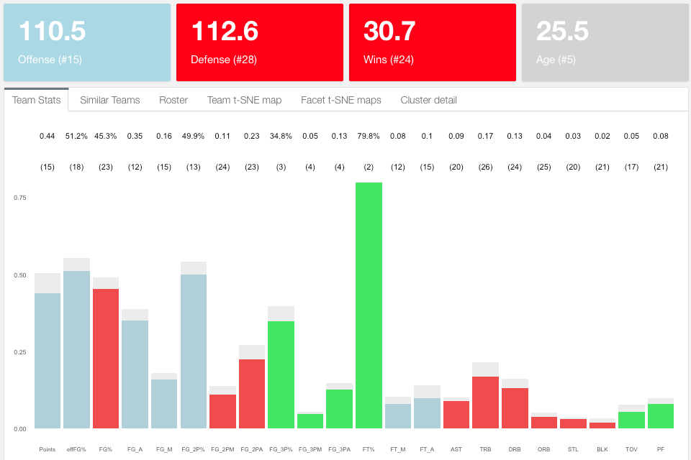Let’s focus on Boston again and let’s look at their stats dashboard without Gordon Hayward:

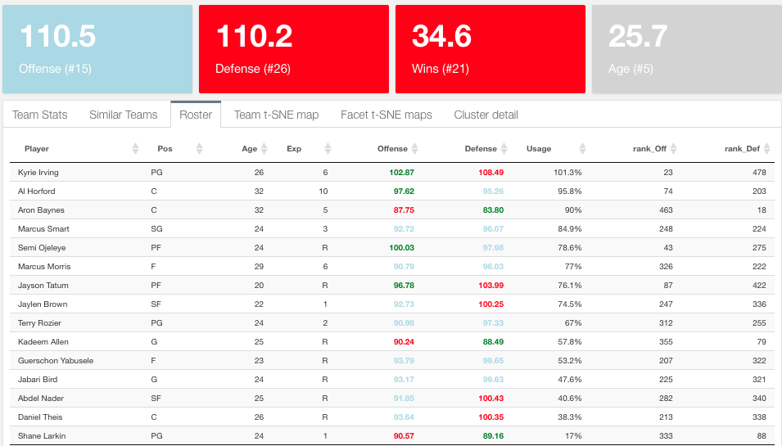Boston gets worse as expected although the drop is not dramatic: Gordon Hayward only represents half a win. The defense seems to improve though. Let’s now increase the usage of Aaron Baynes from his current 13.1 to 30 minutes per game[16] and see how this further impacts the team:

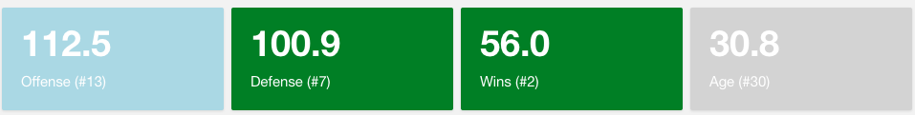Using more minutes of Baynes on the court improves Boston wins by 4. I could continue this pattern to improve Boston enough to be a playoff team. Similarly, here is the impact of Isaiah Thomas’ injury on the Cavs:

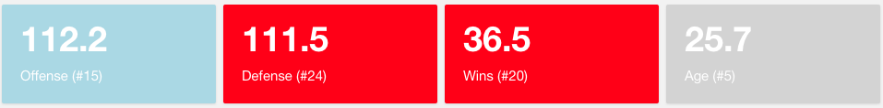Although there is a drop in offense, the defense gets better as players like Tristan Thompson will play more minutes. Consequently, the number of wins increases by 1.5. We can see the ripple effects of Isaiah’s injury for Boston, improving its predicted wins by 1.5[17]

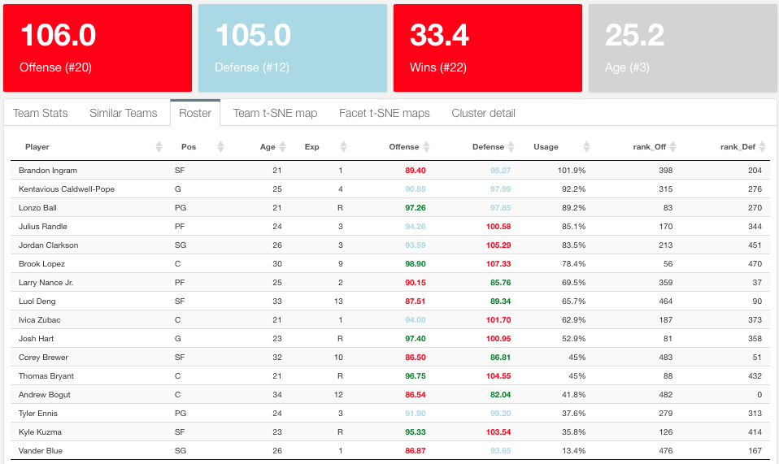What would happen if I trade LeBron to the Lakers? This is the Lakers before LeBron:

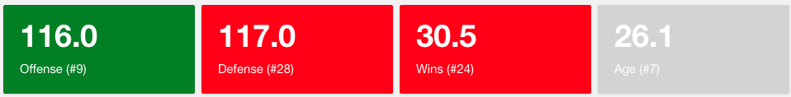After acquiring LeBron James the offense improves but the defense needs tweaking just as with Boston. By default, a star player will get you more baskets but someone has to help in defense.

What happens to a LeBron-less Cleveland? 4.5 fewer wins and 7 fewer offensive points:

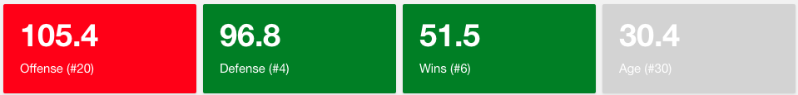

* 1. **Create your own player**

Why stop there? I can create my own player and plug it into any team. This will also allow me to understand how the neural network picks up the stats and return offense and defense outputs. I added a dashboard on the R dashboard to play with it:

I am going to create a player with my name and make him really good in rebounds, steals and blocks. Precisely what Cleveland is lacking the most. Then I will trade myself to the Cavs and check out the results:

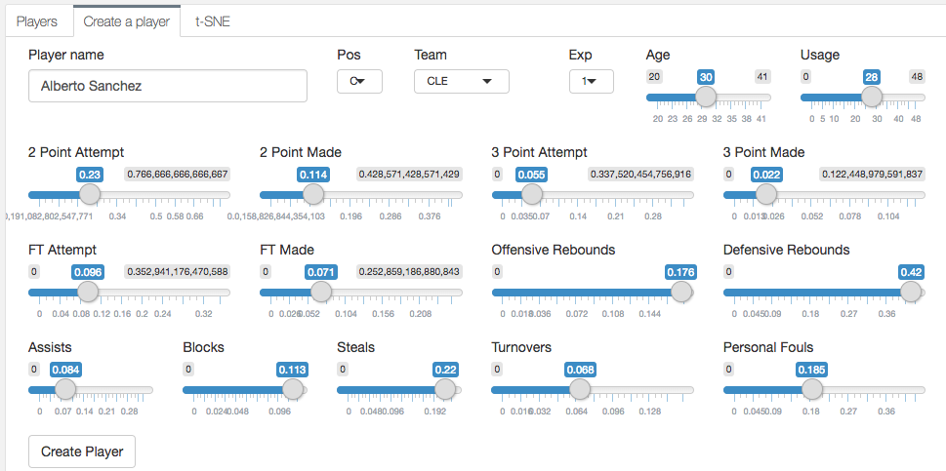1. Create the player: Trade market section on the R dashboard, “Create a player” tab:

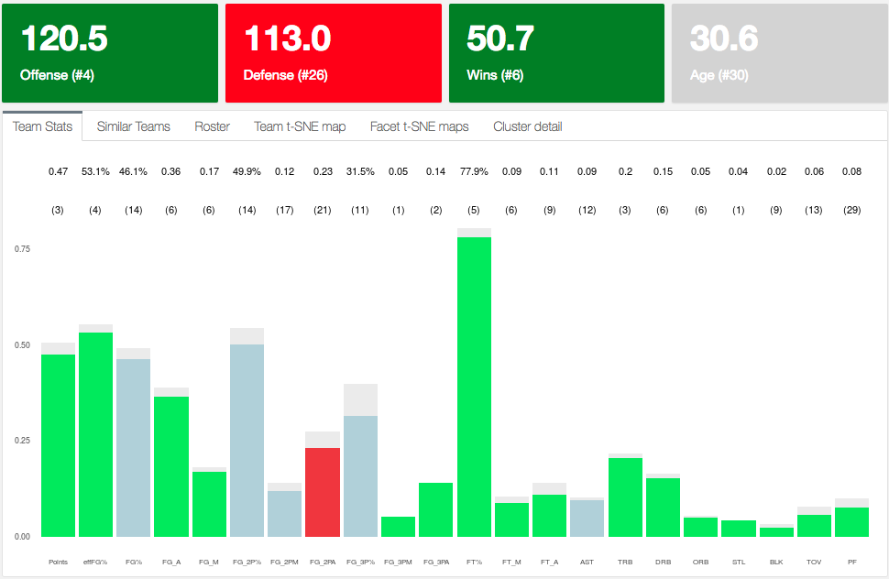2. Check the stats: Now almost all categories are green. However the number of wins decreases

3. Even though I just created the best defensive player of the league and the best 2-way player[18], he takes away a big share of playing minutes[19] from good defensive players: Shumpert (-6.7%), Korver (-6.1%), Green (-5.7%), Frye (-5.8%), etc.:

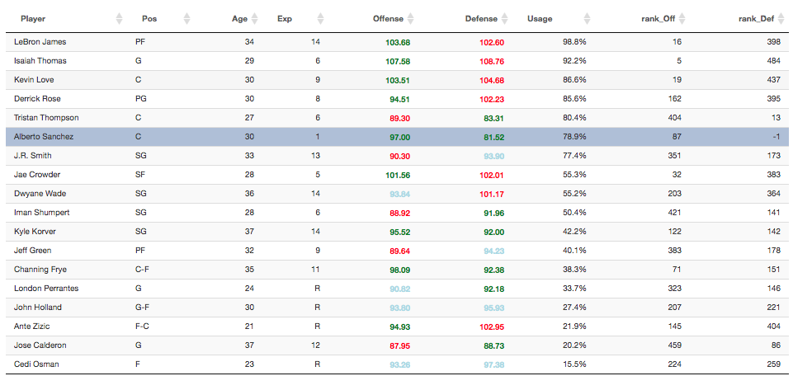

The possibilities are almost infinite and it’s so much fun to play with it.

1. **Conclusion**

The results section

**References**

[1] Basketball Reference. (2017). Retrieved from: https://www.basketball-reference.com/

[2] Reference #2

.

.

.

[n] Reference #n

**Appendix A: R scripts**

**A.1. Neural Network model**

1. write_playersHist.R returns: playersHist.csv
2. .rename_PlayerName_Duplicates.R() from rename_PlayerName_Duplicates.R
3. .team_prepareAll() from prepare_rosters.R
4. .computeModel_neuralnet() from neural_network.R

7. neuralnet default parameters:

neuralnet(formula, data, hidden = 1, threshold = 0.01,

stepmax = 1e+05, rep = 1, startweights = NULL,

learningrate.limit = NULL,

learningrate.factor = list(minus = 0.5, plus = 1.2),

learningrate=NULL, lifesign = "none",

lifesign.step = 1000, algorithm = "rprop+",

err.fct = "sse", act.fct = "logistic",

linear.output = TRUE, exclude = NULL,

constant.weights = NULL, likelihood = FALSE)

**A.2. Predicting Player Skills**

**A.2.1. Returning players (cases a and b)**

.computePredictedPlayerStats() from write_teams_predicted_stats_new_season.R which returns: playersNewPredicted_Oct20.csv

The algorithm runs through all players from last season and computes: .predictPlayer() (from similarityFunctions.R). In particular:

* Top 10 similar players: run .similarPlayers() (from similarityFunctions.R): Using .tSNE_dist()
* Now calculate average variation in their stats when they went from current age to age + 1. Use .tSNE_prepare from similarityFunctions.R).
* Final precaution, make sure no shooting percentages are > 1: playersNewPredicted <- mutate_at(playersNewPredicted, vars(contains("Per")), function(x) ifelse(x >=1, quantile(x,.99), x))

**A.2.2. Rookie players (cases c and d)**

The basic algorithm is write_RookieStats() from write_rookiesDraft.R which returns rookieStats.csv. Here are the details:

To run the algorithm I need to prepare the following files:

* 1. rookies.csv (writeAllRookies() in write_rookiesDraft.R): Retrieves all rookies in the current rosters (The Experience field = “R”) with no stats records. I need to match this file with Players in this file:
  2. collegePlayers.csv (write_CollegePlayers() in write_rookiesDraft.R)

These 2 files are retrieved from different tables in basketballreference and sometimes their names are spelled differently. I have to manually change these:

collegePlayers[grepl("Nazareth Mitrou-Long",collegePlayers$Player),]$Player <- "Naz Mitrou-Long"

collegePlayers[grepl("Royce O'Neale",collegePlayers$Player),]$Player <- "Royce O'Neal"

collegePlayers[grepl("Jacorey Williams",collegePlayers$Player),]$Player <- "JaCorey Williams"

collegePlayers[grepl("Andrew White III",collegePlayers$Player),]$Player <- "Andrew White"

collegePlayers[grepl("TJ Leaf",collegePlayers$Player),]$Player <- "T.J. Leaf"

collegePlayers[grepl("Frank Mason",collegePlayers$Player),]$Player <- "Frank Mason III"

collegePlayers[grepl("Akim Mitchell",collegePlayers$Player),]$Player <- "Akil Mitchell"

For unmatched players, I will query the European database for players for their stats in either the Euroleague, domestic league or overall and match them with players in rookies.csv.

For those still not matched, if they are international players (playing in Europe or not) they are assigned the means of all the stats of players coming from Europe. For the rest (college players who for some reason were not matched or found) I assign the means of the stats of rookie college players.

**A.2.3. Putting it all together**

current_rosters.csv contains players and teams as of Otober 20 2017, that is right at the start of the new season and it’s obtained from: .getLatestRosters(thisSeason="2017",previousSeason = FALSE) from write_teams_predicted_stats_new_season.R

Now I will merge this file with the previously calculated stats for returning NBA players and rookie players described in 3.5.1 and 3.5.2. If everything worked well, there will only be non-matching players because of spelling differences. In case not, and there are still players who were added last minute after we run 3.5.1 and 3.5.2, then we can run: .computePredictedPlayerStats_Leftovers() # from compute_PredictedLeftovers.R.

These are the unmatched players due to spelling differences:

current_rosters[which(current_rosters$Player == "Gary Payton II"),]$Player <- "Gary Payton 2"

current_rosters[which(current_rosters$Player == "Glenn Robinson III"),]$Player <- "Glenn Robinson 2"

current_rosters[which(current_rosters$Player == "Kelly Oubre Jr."),]$Player <- "Kelly Oubre"

current_rosters[which(current_rosters$Player == "Nene"),]$Player <- "Nene Hilario"

current_rosters[which(current_rosters$Player == "Taurean Prince"),]$Player <- "Taurean Waller-Prince"

current_rosters[which(current_rosters$Player == "Tim Hardaway"),]$Player <- "Tim Hardaway 2"

current_rosters[which(current_rosters$Player == "Sheldon Mac"),]$Player <- "Sheldon McClellan"

1. https://alberto-sanchez-rodelgo.shinyapps.io/Player_Dashboard/
2. See for example: https://www.basketball-reference.com/leagues/NBA_2017_per_game.html
3. For a more formal justification see: http://andrewgelman.com/2014/02/25/basketball-stats-dont-model-probability-win-model-expected-score-differential/
4. See Appendix A for details on the R code. Also on my Github: [asRodelgo/NBA](https://github.com/asRodelgo/NBA)
5. See “Should I standardize the input variables?” in http://www.faqs.org/faqs/ai-faq/neural-nets/part2/
6. https://cran.r-project.org/web/packages/neuralnet/neuralnet.pdf
7. http://topepo.github.io/caret/index.html
8. https://lvdmaaten.github.io/tsne/
9. https://projects.fivethirtyeight.com/carmelo/
10. For example, roster for Boston: https://www.basketball-reference.com/teams/BOS/2018.html
11. I use player finder: https://www.sports-reference.com/cbb/play-index/
12. European players: https://www.basketball-reference.com/euro/players/
13. I froze rosters as of October 20, 2017. There may have been a few trades since then.
14. https://en.wikipedia.org/wiki/K-means_clustering
15. https://en.wikipedia.org/wiki/Bhattacharyya_distance
16. 13.1 = 0.003328252/3936. See equation (2)
17. Offense and Defense powers changed slightly as well as the algorithm that reassigns minutes introduces a “jitter” to break ties for the 7th-8th spot on the roster.
18. His plus-minus (Offense - Defense) = 15.48 and adjusted plus-minus =
19. According to the rule by which top 7 players account or 60% of total playing time. See 3.5.4.